LabVIEW Style Guide for SNS

Summary

This document describes the preferred way of creating a LabVIEW-based instrument for the SNS Diagnostics Department. It is a work in progress and contributions from developers are expected. The Guide assists you in creating your program and accompanying documentation. Is also describes procedures to get the instrument commissioned. Several templates are available to base your program on. Each template supports communication with EPICS, the controls system. The documentation and development tool VIHierarchy is to be used to create HTML documentation of your program and assist you during the project development.

Much of the documentation isn’t completed and this document doesn’t satisfy its own rules yet. There will be documentation on the use of VIHierarchy, additional description of the Template, documentation on the EPICS interface, and more details on about everything.

Documentation

There are two parts to your documentation of the software of your diagnostic application. The first part describes the parts of the program similar to how you would (should) document C subroutines. This documentation should help you or another programmer to understand the program and support making changes to the program. The second part of documentation should be a users manual explaining how to use the diagnostic application.

Program Documentation

You can use the VIHierarchy Utility to create HTML files as on-line program documentation. Use the SNS_Template.vi as the example of how to write this part of your documentation. You should include the following documentation:
- All indicators and controls should have their description fields filled out explaining their use.
- The VI info field should explain the operation, use, and dependencies (or assumptions) of the VI and have a version, date, and author field. The dependencies or assumptions should describe the limitations of the algorithm.
- Your diagram must have ample text to explain each section of the VI diagram.

User Manual

The user manual should describe the application from the user point of view. Details of how the functionality is implemented should be in the program documentation. The user manual should include:

- Purpose/Overview of application
- Hardware configuration and hardware settings
- Tuning and calibration procedures
- List of EPICS variables and their descriptions (can be in the form of an EPICS database file)
- List of possible errors and recovery procedures
- Performance specifications
- Description of the user-interface and how to operate the program

Example Programs

A series of example programs has been created to demonstrate the use of the EPICS Shared memory library and to lead up to the full-featured template. The first example is a bare bone EPICS application while consecutive examples add more features. Each example functions as a server and comes with a client program to set control points (an EPICS out) and read results (an EPICS in).

Basic1 Example

The basic example demonstrates how to perform read and write accesses to EPICS PVs. The program multiplies the DAC value with the coefficient to obtain the ADC value. A state machine implements three states (init, run , exit). The only initialization action is to start the EPICS IOC. In the Run state there are two PVs that are read (set by a remote client) and one result that is set (read by a client). There are no readbacks PVs implemented for the client thus the client can’t read the settings. There is no error handling, no interrupt handling, no auto PV database generation, no event structure, no use of queues, no multiple tasks.

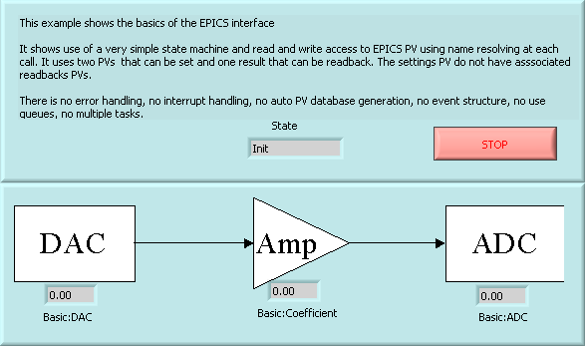
Figure 3-1. The front panel from the basic1 example.

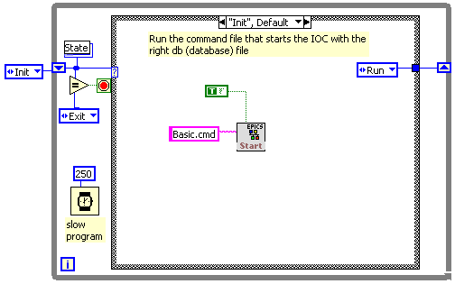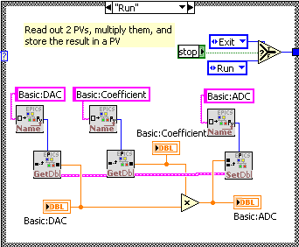

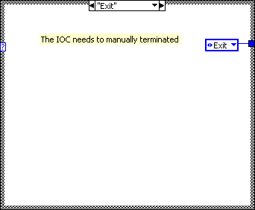
Figure 3-2. The diagram shows the three states of the basic1 VI: Init, Run, and Exit.
In the Init state the IOC is started by executing the Basic1.cmd file. The IOC will then load the defined PVs from the db file. As the PVs are created the Shared Memory entries are also created and now the LabVIEW program can access the PVs. The Init state sets the next state to be Run. Also note that each iteration has a 250 msec wait to slow down the program. The access of the PVs is done in the Run state. Each PV name is passed through the Name to Index resolver to get the Index of the PV which is used to either retrieve the value or set a value. Note that resolving a name to an index takes up time, the next example will solve that problem. If the stop button is clicked then the next state will be Exit otherwise the next state will be Run again. Currently there is no IOCstop VI that would have been placed in the Exit state.

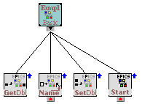
Figure 3-3.The subVIs of the basic1 Example.

You can check the operation of the program with a Channel Access client such as EDM or the included LabVIEW Channel Access Client, Example_Basic1_Client.vi. In this client you can set the DAC and coefficient and read the ADC value from the same or a different computer.

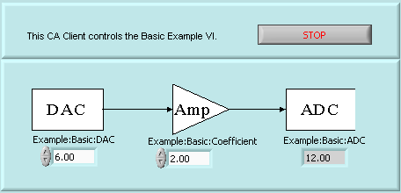
Figure 3-4. The front-panel of the LabVIEW Channel Access Client for the basic1 example.

Basic2 Example

The basic2 example adds more features the basic example:

- PV name resolving at initialization: This saves time during operation as the resolving only happens once and not every cycle. The PV indices are stored in named globals. The VI that does the name resolving has the name of the project in it, "basic2" and the string "GetPVs". The VI SM_GenerateDB.vi from the SM.llb find the VI with the string "GetPVs" in it and calls it after setting a flag from run to compile. Instead of doing the name resolving the "GetPVs" now collects VI and generate the db file, the command file, and a documentation file with xls (Excel) extension. There are two PVs that can be set and one result that can be readback.
- Error Logging: the errors for each state are sent to an error logging facility, the errors are written to the front-panel and sent to a standard EPICS PV.
- Readback devices: The settings PV have associated readbacks PVs so that an operator can see what the current values are before he/she makes a change.

The initialization now not only starts the IOC but also does the name resolving and the initialization of the Error logging. The Run state now also updates the readback devices. The Exit state is still pretty much empty. There is no Error state to deal with potential errors but, most likely, you will want to implement one to recover from an error condition by, e.g. reinitializing the hardware.

The VI, Basic2_EPICS_GetPVs.vi resolves the name to Index but also declares the type of PV. A cluster is used to define:
- Type of element: Double, integer, string ,etc.
- Record type: In or Out (EPICS in is a result from LabVIEW, EPICS out is a PV that LabVIEW reads).
- Number of elements: 1 for a scalar, >1 for a waveform.
- Scan type: Passive (use for out records) Scan, with period defined (use for input records) and I/O Intr (use for input records created on an interrupt).
- Scan period: update interval in seconds.
- Interrupt Group: Not used in this example (used to group inputs together to give them the same timestamp or for use with interrupt driven commands).

Specifying the above cluster is enough information to generate an EPICS .db file. The VI SM_GenerateDB.vi, see Figure 3-1, will do that You can specifiy more attributes, this will be discussed in following chapters.

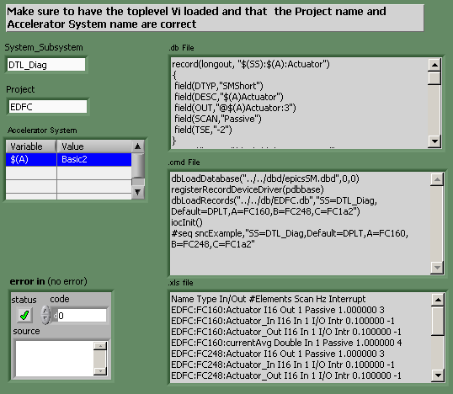
Figure 3-5. The front-panel of SM_GenerateDB.vi

The PV indices are stored in a VI global, see Figure 3-7, called Basic2_EPICS_Globals.vi. Such a VI must be made for each application. The global holding the index for the messages is stored in a global VI from the EPICS library as this global is referred by several EPICS VIs. If this global was also stored in the customized global then several EPICS VIs would have to be changed for each application.

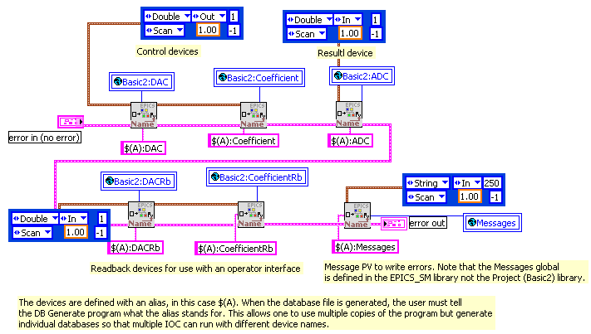
Figure 3-6. The diagram of the VI that resolves the PV names to indices.

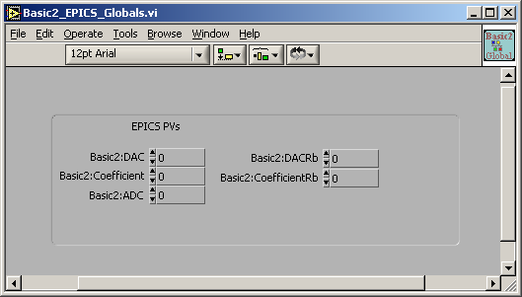
Figure 3-7. The global that holds the indices of the PVs.

Note that there are now three PVs from the basic example, two PVs to provide readbacks, and one PV to display the error messages (the references to it are in the Log Error VIs).

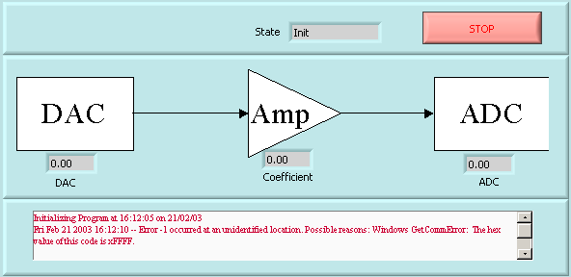
Figure 3-8. Front-panel of the Basic2 Example.

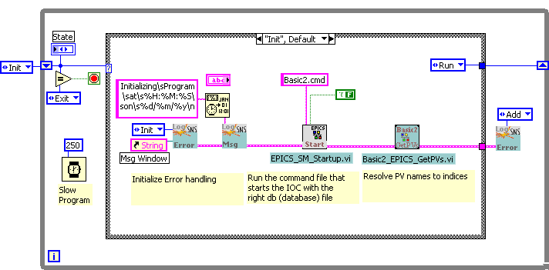
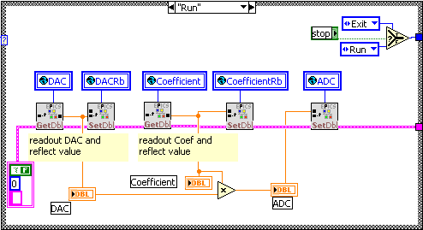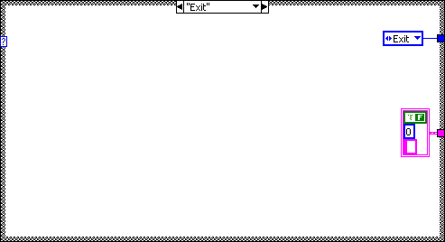

Figure 3-9. The diagram of the Basic2 Example.

The front-panel and diagram are shown in Figure 3-8 and Figure 3-1. Note that the error cluster is passed from VI to VI and then to the Log Error VI. One could also log the errors per each VI. Often the VIs are written such that when the error cluster contains an error the VI will not execute but just pass the error on. Whether the VI ignores the error or not is up to the programmer. The error cluster can also be used to decide what will be the next state. For example, if an error occurs in the data-acquisition, one could make the next state the initialization of the hardware to try to recover from the error.

The client for the basic2 example is shown in Figure 3-10. The readback value (the reading of the setting) can be different from the setting value if there is another task setting the value. This happens during initialization of the Basic2 example. In the Basic3 example, one can interactively set the setting from the Toplevel (server) VI.

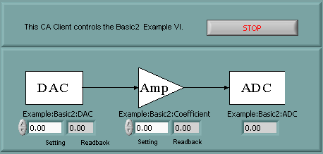
Figure 3-10. The Client for the Basic2 example.

Basic3 Example

The basic3 example adds the following features over the basic2 example:
- Event structure: Capture activity on the front-panel without polling overhead.
- Multiple Tasks: One task for the user interface and one task for the data processing.

The event structure in the User Interface Task captures the event of when a front-panel control changes it value. This method avoids having to poll and compare old values. There are three events defined for this event structure:
- Timeout: The structure times-out every 500 msec to be able to see if the loop must be terminated.
- Basic2:DAC control value changed: When this changes value then set the PV for that control to the new value.
- Basic2:Coefficient control value changed: When this changes value then set the PV for that control to the new value.
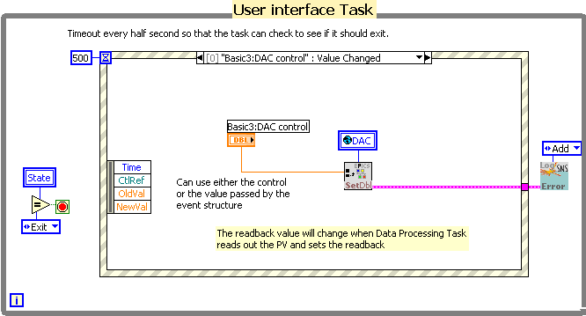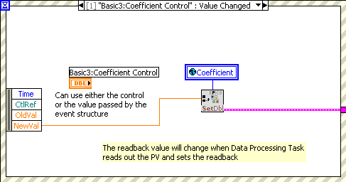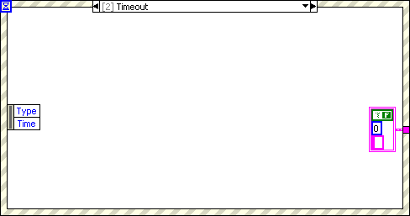
Figure 3-11. The Diagram of the Basic3 User Interface Task.

This simple user-interface doesn’t use a state machine. It knows when to stop by checking to see if the Data Processing Task has entered the exit state. The event structures must use the time-out to check the exit condition because the event structure (of LV 6) doesn’t allow for programmable events. Only events from the front-panel can be captured. The two tasks “communicate” using a local variable. A more generic method would be the use of queues. That way, the two tasks don’t have to share the same front-panel in order to use the same local variable (although one could use a global variable or a reference to a local variable) and commands can be queued. Also one can obtain a queue reference using the name of the queue at any point in any diagram.

Use Example_Basic3_Client.vi to remotely operate.

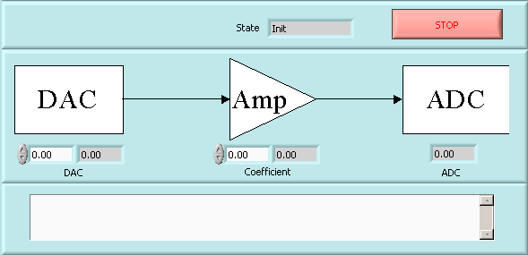
Figure 3-12. Front-panel of the Basic3 example.

Description of the Templates
Several Templates have been made to serve as examples for the programmer. The templates show different ways of implementing a program. If you decide to build your program on one of templates, use the VIHierachy utility to clone it. VIHierarchy allows you to rename the VIs while keeping the hierarchy intact and save the VIs to a new directory.
Each template uses the state machine, a case structure wired to an enumerated integer, to implement the program. The state machine allows the programmer to jump to a next step in the program depending on what happened before

Polling Template

While polling is potentially not as processor efficient and as responsive as an interrupt driven program, it can lead to simpler programs. If you have a program that doesn’t need the full speed of the processor and can handle if a response comes only after the scan period then this is an excellent way to go. The VI Template_Poll_TopLevel.vi shows an implementation that uses polling to see if there is local or remote user activity or if there is data ready for processing. It needs only one task (while loop) to implement the program. Because there is just one task, there is no need for queues to communicate between the tasks. The initialization starts the IOC, see Figure 4-13. The references to the front-panel controls and indicators (local user I/O) are collected and inserted into the settings so that subVIs can read or update the controls or indicators as needed.

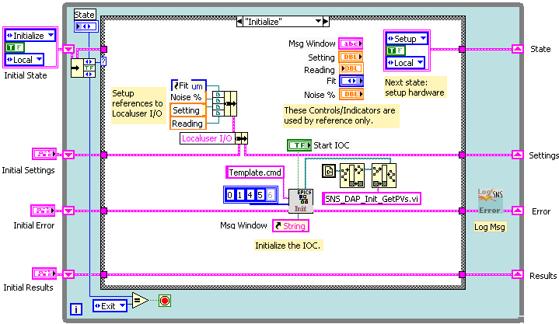
Figure 4-13. The Diagram of the polling example.
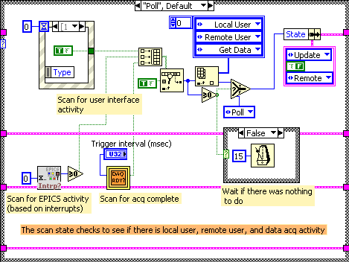
Figure 4-14. The Poll state of the Polling VI .
All local user I/O is registered in just one case of the Event structure with a zero second wait. The structure returns FALSE if there was no change in any value but TRUE if there was a change. If the structure returns TRUE the next state will be Local User. This state reads out the buttons to determine what the next state should be. Note that the polling only handles one TRUE at once and ignores the others. The first TRUE in the array will be handled. Thus the Remote User or Data Ready will be ignored if TRUE as well. During normal operation there is only the remote user, so this should very rarely happen. Ignoring the Data Ready is not bad if the data is still ready on the next poll. Note that there is no delay to the next poll if there was an action so that the delay on the processing of the data is only as long as it takes to process the setting change without an extra scan period. If a setting would disrupt the data that is ready, you can make the Data Ready the first activity found by wiring it to the first element of the build array primitive. If you don’t want to skip any activity, then use a global, local, or register to remember other activities that were TRUE for the next Poll state.
This example uses the interrupts to group together the settings PVs to determine if there is remote user activity. The SM_InterruptWait.vi with a zero second wait period is called to see if there are any PVs that have been remotely updated. If you don’t use this method you could readout all the Settings PVs and compare to previous values to determine if there was a change. This example assumes that if there was a setting, it was a change, and then, for simplicity, reads out all PVs to get new settings (in the Setup state). If there was a remote change, the next state is Remote User. This state determines what the next state should be. Currently, the only control from a remote user is to change the setup so that all that needs to be done is to go to the Setup state and use the remote settings to setup the virtual hardware.
If the Data is ready then the next state is Get Data to read the data out. The next state is Analyze to process the data followed by state Update Local and Update Remote to update the local and remote displays. For efficiency the local update can be turned off.
If there was no activity found then the program waits and reenters the Poll state.
The State Setup includes the initialization. The initialization is typically only called once during setup but could also be a remote command. To command that sets the next state also includes a Boolean to decide if there should be an initialization. Note that the Initial State constant has this Boolean set to TRUE. To decide whether the settings should come from local or remote values, there is another parameter passed along with the State name. This is an enumerated constant set to either Local or Remote. In this program the switch is set to local if the local user was the last one to do a setting or remote if there was a remote change. If there are multiple parameters that have different local and remote settings, you will see the reading switch all at once to either the remote or local settings depending on which had the last change. The readbacks, local and remote, are updated no matter whether the last update was due to a remote or local change. The programmer can always implement different behaviors. LabVIEW does allow to set a control programmatically, EPICS is not yet fully supporting bidirectional (or multi-master) PVs. The operation of the other states can be seen by inspecting the LabVIEW program.

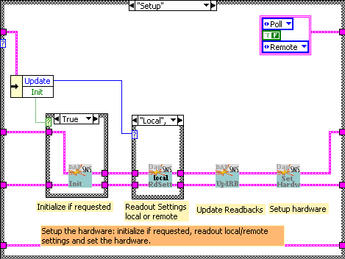
Figure 4-15. The Setup State of the polling template.

This template implements together with the CA_Client_InOut_Example.vi a demo of how a setting/readback pair can be implemented. Both LabVIEW and the remote CA client have their own setting but both will get a reading of the current setting.

Event Driven Template
Using event driven program means that no time is lost during scans to see if anything has happened. Whenever an event happens, the code will react quickly. This means that there is no scan period where no action can be taken. Thus an event driven implementation can react faster. When dealing with external code to retrieve data, there are two ways to implement event driven programs in LabVIEW (6.1). One way is to run a blocking call in a separate task that only returns when something happens followed by setting an occurrence or by queuing a message. Another way is to have the hardware library, likely written in C/C++, call the set_occurrence function (NI uses this as a DAQ event) while a part of LabVIEW is waiting for the occurrence. The tasks call a wait function on a queue or occurrence and will continue only when there is a message or occurrence.

This version uses multiple tasks to implement an event/interrupt driven program. The tasks in the Template are coded right on the diagram of the toplevel VI. If one wants to assign different priorities to the tasks, the tasks should be converted into subVIs (from the Edit menu).

The template uses four tasks (while loops) to support:
- The local User-Interface (UI) and Network Initialization. This is where you can use the front-panel controls and the event structure to react to user events and issue command to the Command Execution task. In the current version of LabVIEW, 6.1, programmatic changes to controls cannot be reacted to by the event structure and therefore EPICS task events cannot be directly passed on to front-panel controls using references. Once this capability is present, the UI and Command task can be merged.
- A Command Execution (CE) task to execute commands requested by the EPICS or local UI. Implement the actions to be taken when users click or modify controls through the UI or through EPICS.
- The Data Acquisition and Processing (DAP) task to acquire and process the data. Implement your hardware setup, data-acquisition, data processing, and EPICS PV updating here.
- An EPICS task is run as a thread in the background to do a blocking wait on interrupts. As soon as the interrupt is there the task awakens and sends the information to the CE queue

Communication between tasks is done using globals/PVs and queues. The globals and PVs are used to share information about settings or results. The queues are used to synchronize or issue commands.

Tasks in Simplified version
The template uses three tasks (while loops) to support:
- The local User-Interface (UI) and Network Initialization. This is where you can use the front-panel controls and the event structure to react to user events and issue command to the Command Execution task. In the current version of LabVIEW, 6.1, programmatic changes to controls cannot be reacted to by the event structure and therefore EPICS task events cannot be directly passed on to front-panel controls using references. Once this capability is present, the UI and Command task can be merged.
- The Data Acquisition and Processing (DAP) task to acquire and process the data. Implement your hardware setup, data-acquisition, data processing, and EPICS PV updating here. Now this tasks also processes the commands by EPICS. If the commands are simple then this simplified structure can be used.
- An EPICS task is run as a thread in the background to do a blocking wait on interrupts. As soon as the interrupt is there the task awakens and sends the information to the DAP queue

Communication between tasks is done using globals/PVs and queues. The globals and PVs are used to share information about settings or results. The queues are used to synchronize or issue commands from one location in the program to another. For example, the EPICS interrupt task wants to alert the DAP task that an interrupt has happened. The DAP task when it is idling checks this queue and gets the command.

Task in Cycle Version

The cycle version demonstrates how to use the template to implement an instrument that cycles quickly such as a BPM or BCM. One loop is now dedicated to acquiring the data and sending it to the analysis task (still called the DAP task). The Data Get (GD) task will try to run as fast as possible and send data through the queue to the DAP task. In this example the queue is only 10 deep to avoid running out of memory. If the queue is full the DG task will have to wait until it can enter another data set. This automatically syncs the two tasks.

- The local User-Interface (UI) and Network Initialization. This is where you can use the front-panel controls and the event structure to react to user events and issue command to the Command Execution task. In the current version of LabVIEW, 6.1, programmatic changes to controls cannot be reacted to by the event structure and therefore EPICS task events cannot be directly passed on to front-panel controls using references. Once this capability is present, the UI and Command task can be merged.
- The Data Acquisition and Processing (DAP) task to sets the hardware and processes the data. Implement your hardware setup, data processing, and EPICS PV updating here. The data-acquisition is done by the DG task
- The Data Get (DG) Task gets the data from the hardware but doesn’t set it, this is done by the DAP task.
- An EPICS task is run as a thread in the background to do a blocking wait on interrupts. As soon as the interrupt is there the task awakens and sends the information to the DAP queue. If no interrupt driven EPICS communication is needed, this task can be removed.

The Template shows the use of the state machine to implement executing bits of code Description

The Template shows the use of the state machine to implement executing bits of code depending on the state of the system. For example, if an error occurs during acquisition, one should not proceed to data-analysis but instead go to the error state and try to recover from the error by for example reinitializing the hardware. The state machine allows you to write easily reviewed code that allows a dynamic change in the flow of control.

The template uses the event structure to monitor the use input without the need for polling. At this time only user input can be captured and not programmatic events.

Multiple while loops are used to implement task that need to run in parallel. communication and synchronization between the tasks is done using queues for commands and globals for settings. The queue’s element structure has the command and a string to describe the parameters. This way the state machine can be parameterized in case the operation of a state must be modified in a slight manner such as change the parameters of the analysis. The registers of the while loops are used to store data or settings that need to be used while the task is running. The DAP task stores the setting and results this way so that each state can read these and modify as required.

UI Task

When starting the program, only the UI task is allowed to proceed, the other tasks CE and DAP must wait for a command, while the EPICS task is started explicitly by the UI task. The UI task loads the error database (see Error Handling) and resets the message window. It then calls the VI SNS_Template_EPICS_Startup.vi which calls asynchronously a task (SNS_Template_EPICS_Task.vi or SNS_Template_EPICS_TaskSimple.vi) that calls the EPICS dll in a blocking manner. The dll will block until an interrupt is set either through record processing or by LabVIEW itself. When awakened the VI will issue a command into the specified queue to warn another task that EPICS has issued an interrupt. For the dll to return on interrupt, each interrupt must be connected first using the VI SNS_EPICS_InterruptConnect.vi.
In a future version this part of the program will also start the IOC and wait for it to be running, for now this must be done manually. The UI Task will now send a command to the CE task (or DAP task in case of the simplified version) to continue. The UI task will no proceed to the event structure to handle the local user commands. The structure will timeout every 500 milliseconds to check if the Net Stop global is false and the program must end. If so the task goes to the exit state to set interrupt 0. This will awaken the EPICS tasks and tell it to exit. Next it will send the exit command to the CE or DAP task and issue an Exiting Program message.

CE Task

The CE task initializes by issuing a Initialize command to the DAP task. It will now wait for a command to itself from either the UI task or the EPICS task. It handles commands such as trigger and reanalyzed. It also implements the EPICS command handling. The EPICS command handling is through the PV TPL_Command. This is an array of which the first element is a command and the reaming elements are parameters. The allowed commands are shown in Table 1. Note that the command values are the same as the enumerated values of the states of the DAP task. When the task is told to exit it will pass the exit command on to the DAP task.

Command Value | Action
3 | Initialize DAP
4 | Setup Hardware (readout PVs and globals)
6 | Trigger
7 | (Re)analyze
9 | Update PVs
Table 1. Command values accepted by the Template

DAP Task

The DAP task initializes by setting the hardware and resolving the names of the PVs to indices. For the template no real hardware is present instead a simulation is set. The initialization uses the Configuration File Vis from NI to readout default configuration values from disk. These VIs are very handy and use files that can be edited with simple text editors. The names of EPICS PV are resolved to indices so that the PV read or write operations are executed faster.

The initialization takes references from front-panel indicators to pass on the values to the lower level VIs to give some EPICS PVs an initial value.

All values for the simulation (hardware) are now know. The VI SNS_DAP_ReadSettings.vi reads out the globals and PVs and stores them in the setting structure to get one consistent set for the simulation (hardware). The advantage of reading out all settings at once and in one location is that you can get a consistent set. It doesn’t matter if someone now changes the global (local user) or PV (remote user). It will not get used until the VI SNS_DAP_ReadSettings.vi is called again (through a DAP Queue command). Also by keeping the readout in one place the program becomes easier to review and maintain. One avoids having to look through many pieces of code to find the one location where the setting was readout.

The DAP task now waits until a command is issued. The command is the state to go to and the parameter string. By clicking on the Trigger button, the DAP task proceeds to generate (acquire) the data. Two gaussians are generated. The next state analyzes the data unless an error occurred in which case the simulation (hardware) will be setup again. After the analysis the data is displayed on the main screen. Next the results are written to PVs again in one location only to ease the maintenance of the program. The DAP task now returns to setup the hardware and then wait for a command (trigger). Note that if you have hardware and want to do a blocking wait for completion you should not use this setup. Instead one can create a thread much like the EPICS thread that will send a command with acquired data to the DAP task.

Application Programming

To create an easier to maintain overall diagnostic system, each type of diagnostic program should look similar to the other. Each system should be similarly structured and use the same style of programming. A Template VI has been created that programmers can use to get started. A SNS LabVIEW Programming Style Guide provides guidelines and specifications on how to implement and document the program. The previous chapter supplied guidelines for documentation which is also part of the programming.

Getting Started

A template VI called SNS_Template.vi get you started. It provides you with a general structure to setup your communication with EPICS, the local user interface, a command task to execute requests, and a data-acquisition and analysis task. The template should fit most type of acquisitions. It is assumed that you will have a program that acquires data and must communicate the results to the control system. You will have control over the operation of your instrument over EPICS as well as an optional local user interface.

Program Style Guide

At this point I have only some very general guidelines. Read the Development Guidelines published by national Instruments. This guide presents several the development models, how to prototype and test. Notice the Good Wiring Techniques in Chapter 6 and the VI, Front Panel, and Block Diagram Checklists. In particular:

- Wire left to right as much as possible, use the dataflow model as is intended in LabVIEW.
- Use a small block diagram, there should be minimal scrolling (maximum of about half a screen in one direction on a 1024x768 display).
- Use the case structure to implement a state machine to implement complex procedures. As is shown in the template.
- Assume the user of the LabVIEW UI is an experienced LabVIEW user but avoid problems such as that when LabVIEW windows are closed by clicking on the OS close window button the program gets stuck. So do take care of the UI as indicated by the LabVIEW Development Guidelines.
- Always use the error cluster to pass on errors. If there is an error you should include the VI name in the error message. If you set the Boolean to TRUE (error rather than a warning) then following VIs must handle the error, e.g. by not executing their code and passing on the error. The error must be logged with the SNS error handler. You must create a table in which the user defined errors are declared. See Appendix A.
- Use the sequence structure or the error cluster connectors to determine the order of execution.
- In organizing your VIs, You can use the subdirectories and store your VIs there or use LLBs instead of subdirectories but keep the size of the LLBs limited to avoid significant slow downs in reading and writing to the LLBs.
- Minimize the use of globals as they can lead to unintended interactions. Use the globals to store settings (as they might be set from different tasks (while loops)) but read the globals out before using the settings in the hardware control VIs.
- When external files are used for code fragments, DLLs, or configuration locate these under C:\LabVIEW and use subdirectories as needed to organize these files. The EPICS files are stored are required by the IOC.

EPICS INTERFACE

The EPICS interface is based on a shared memory access between IOC and LabVIEW.
You can read and write to the shared memory from within LabVIEW. The PVs can be grouped together into interrupt groups. This way they will have the same time-stamp (as entered in the call to the Set interrupt VI. It is recommended to group together the reads and writes as much as possible. In particular, when using EPICS PVs as settings, read these out only after an EPICS command to update “Setup Hardware” in DAP task in the template. This way a program or operator can modify multiple settings in sequence without the LabVIEW program updating its setup and possible getting a hardware trigger in between settings and making a measurement with an inconsistent set of parameters. After the updating of the setting parameters is done, you should issue one final setting on the Command Register PV to indicate that the hardware must be setup. You will now have a consistent set of values to set your hardware.

CHANNEL ACCESS EXAMPLES

A couple of VIs have been created to demo the operation of the Template. These VIs use the Channel Access Client with ActiveX as written by Kay Kasemir from LANL.

CA_Client_XYarray_example.vi | Plots the Profile of the simulated Gaussian with Fit
CA_Client_GetDouble_Example | Gets a PV of double type and displays the value
CA_Client_InOut_Example | Show how to use two PV to implement a setting and reading
Table 2 Channel Access Client program to demo the operation of the IOC Shared Memory template.

Error handling

While error handling is a lot of work to implement, it must be done to ne able to diagnose problems and end up with reliable diagnostic systems. If there is a problem, the system must return into a state that doesn’t harm the accelerator. This is not a problem for a BPM system but a wire scanner with actuators must try to withdraw the wire when an error occurs. Several Error handling VIs are included with the template. The idea is that error messages can be stored and displayed within LabVIEW but also made known to EPICS so that operators or studiers will be alerted to error conditions.

Initialization

LabVIEW has a general error handler that is slightly modified to support the needs for the SNS Error handling. User-defined codes and their explanations must be stored in a data file that is read during initialization. The name of the file is C:\LabVIEW\Usercodes.xls. It should be a text-based spreadsheet with the first column holding the user error code and the second column the error description. Use error codes 6000 through 9999. Numbers from 5000 to 6000 are used by EPICS (in the file C:\LabVIEW\EPICScodes.xls) and other platform routines. The call to initialize the error codes database is done by the template in the UI task

Passing on Errors

You can pass the messages about the errors on to the Message Window or to EPICS by using the VI SNS_Error.vi. The default action of the VI is to Add (process) the error. The template calls this VI after each action. You can however catch the error earlier, do the appropriate action and Add the error before you exit your own VIs. Any Error messages are displayed in the Message window on the main front-panel. You can also send messages to this window using SNS_Main_Msg_Add.vi.

Appendix A. DB file

#! Generated by VisualDCT for Java v2.1
record(waveform,"$(user):TPL_Stop") {
field(DTYP,"SMLongOut")
field(DESC,"Abort labVIEW")
field(INP,"@TPL_Stop:0")
field(NELM,"1")
field(FTVL,"LONG")
field(TSE,"-2")
}
record(waveform,"$(user):TPL_Command") {
field(DTYP,"SMLongOut")
field(DESC,"Command")
field(INP,"@TPL_Command:1")
field(NELM,"9")
field(FTVL,"LONG")
field(SCAN,"Passive")
field(TSE,"-2")
}
record(waveform,"$(user):TPL_CommandResult"){
field(DTYP,"SMLong")
field(DESC,"Command Result")
field(INP,"@TPL_CommandResult:3")
field(NELM,"10")
field(FTVL,"LONG")
field(SCAN,"I/O Intr")
field(TSE,"-2")
}
record(longin, "$(user):TPL_Status"){
field(DTYP,"SMLong")
field(DESC,"Status")
field(INP,"@TPL_Status:3")
field(SCAN,"I/O Intr")
field(TSE,"-2")
}
record(ai, "$(user):TPL_Noise_prc")
{
field(DTYP,"SMDouble")
field(DESC,"Noise Percentage")
field(EGUF, "100")
field(EGU, "Percent")
field(INP,"@TPL_Noise_prc")
field(SCAN,".1 second")
field(TSE,"-2")
}
record(ai, "$(user):TPL_Reading")
{
field(DTYP,"SMDouble")
field(DESC,"Reading value")
field(INP,"@TPL_Reading")
field(SCAN,".1 second")
field(TSE,"-2")
}
record(ao, "$(user):TPL_Setting")
{
field(DTYP,"SMDouble")
field(DESC,"Setting value")
field(OUT,"@TPL_Setting:5")
field(SCAN,"Passive")
field(TSE,"-2")
}
record(ao, "$(user):TPL_Gauss_Sig_A")
{
field(DTYP,"SMDouble")
field(DESC, "Gaussian Sigma A")
field(OUT, "@TPL_Gauss_Sig_A:4")
field(SCAN,"Passive")
field(TSE,"-2")
}
record(ao, "$(user):TPL_Gauss_Amp_A")
{
field(DTYP,"SMDouble")
field(DESC, "Gaussian Amplitude A")
field(OUT, "@TPL_Gauss_Amp_A:4")
field(SCAN,"Passive")
field(TSE,"-2")
}
record(ao, "$(user):TPL_Gauss_Amp_B")
{
field(DTYP,"SMDouble")
field(DESC, "Gaussian Amplitude B")
field(OUT, "@TPL_Gauss_Amp_B:4")
field(SCAN,"Passive")
field(TSE,"-2")
}
record(ao, "$(user):TPL_Gauss_Sig_B")
{
field(DTYP,"SMDouble")
field(DESC, "Gaussian Sigma B")
field(OUT, "@TPL_Gauss_Sig_B:4")
field(SCAN,"Passive")
field(TSE,"-2")
}
record(waveform,"$(user):TPL_Pos_Raw_A")
{
field(DTYP,"SMDouble")
field(DESC,"Raw Position A")
field(INP,"@TPL_Pos_Raw_A:2")
field(NELM,"256")
field(FTVL,"DOUBLE")
field(SCAN,"I/O Intr")
field(TSE,"-2")
}
record(waveform,"$(user):TPL_Sig_Raw_A")
{
field(DTYP,"SMDouble")
field(DESC,"Raw signal A")
field(INP,"@TPL_Sig_Raw_A:2")
field(NELM,"256")
field(FTVL,"DOUBLE")
field(SCAN,"I/O Intr")
field(TSE,"-2")
}
record(waveform,"$(user):TPL_Pos_Fit_A")
{
field(DTYP,"SMDouble")
field(DESC,"Fitted Position A")
field(INP,"@TPL_Pos_Fit_A:2")
field(NELM,"256")
field(FTVL,"DOUBLE")
field(SCAN,"I/O Intr")
field(TSE,"-2")
}
record(waveform,"$(user):TPL_Sig_Fit_A")
{
field(DTYP,"SMDouble")
field(DESC,"Fitted Signal A")
field(INP,"@TPL_Sig_Fit_A:2")
field(NELM,"256")
field(FTVL,"DOUBLE")
field(SCAN,"I/O Intr")
field(TSE,"-2")
}
record(waveform,"$(user):TPL_Pos_Raw_B")
{
field(DTYP,"SMDouble")
field(DESC,"Raw Position B")
field(INP,"@TPL_Pos_Raw_B:2")
field(NELM,"256")
field(FTVL,"DOUBLE")
field(SCAN,"I/O Intr")
field(TSE,"-2")
}
record(waveform,"$(user):TPL_Sig_Raw_B")
{
field(DTYP,"SMDouble")
field(DESC,"Raw signal B")
field(INP,"@TPL_Sig_Raw_B:2")
field(NELM,"256")
field(FTVL,"DOUBLE")
field(SCAN,"I/O Intr")
field(TSE,"-2")
}record(waveform,"$(user):TPL_Pos_Fit_B")
{
field(DTYP,"SMDouble")
field(DESC,"Fitted Position B")
field(INP,"@TPL_Pos_Fit_B:2")
field(NELM,"256")
field(FTVL,"DOUBLE")
field(SCAN,"I/O Intr")
field(TSE,"-2")
}
record(waveform,"$(user):TPL_Sig_Fit_B")
{
field(DTYP,"SMDouble")
field(DESC,"Fitted Signal B")
field(INP,"@TPL_Sig_Fit_B:2")
field(NELM,"256")
field(FTVL,"DOUBLE")
field(SCAN,"I/O Intr")
field(TSE,"-2")
}
record(ai, "$(user):TPL_Fit_Amp_A")
{
field(DTYP,"SMDouble")
field(DESC, "Fit Amplitude A")
field(EGU, "Volts")
field(INP, "@TPL_Fit_Amp_A:2")
field(SCAN,"I/O Intr")
field(TSE,"-2")
}
record(ai, "$(user):TPL_Fit_Mean_A")
{
field(DTYP,"SMDouble")
field(DESC, "Fit Mean A")
field(INP, "@TPL_Fit_Mean_A:2")
field(SCAN,"I/O Intr")
field(TSE,"-2")
field(EGU, "mm")

}
record(ai, "$(user):TPL_Fit_Sigma_A")
{
field(DTYP,"SMDouble")
field(DESC, "Fit Sigma A")
field(INP, "@TPL_Fit_Sigma_A:2")
field(SCAN,"I/O Intr")
field(TSE,"-2")
field(EGU, "mm")

}
record(ai, "$(user):TPL_Fit_Offset_A")
{
field(DTYP,"SMDouble")
field(DESC, "Fit Offset A")
field(INP, "@TPL_Fit_Offset_A:2")
field(SCAN,"I/O Intr")
field(TSE,"-2")
field(EGU, "Volts")
}
record(ai, "$(user):TPL_Fit_Slope_A")
{
field(DTYP,"SMDouble")
field(DESC, "Fit Slope A")
field(INP, "@TPL_Fit_Slope_A:2")
field(SCAN,"I/O Intr")
field(TSE,"-2")
field(EGU, "V/mm")

}
record(ai, "$(user):TPL_Fit_Area_A")
{
field(DTYP,"SMDouble")
field(DESC, "Fit Area A")
field(INP, "@TPL_Fit_Area_A:2")
field(SCAN,"I/O Intr")
field(TSE,"-2")
field(EGU, "Vmm")

}
record(ai, "$(user):TPL_Fit_Amp_B")
{
field(DTYP,"SMDouble")
field(DESC, "Fit Amplitude B")
field(INP, "@TPL_Fit_Amp_B:2")
field(SCAN,"I/O Intr")
field(TSE,"-2")
field(EGU, "Volts")
}
record(ai, "$(user):TPL_Fit_Mean_B")
{
field(DTYP,"SMDouble")
field(DESC, "Fit Mean B")
field(INP, "@TPL_Fit_Mean_B:2")
field(SCAN,"I/O Intr")
field(TSE,"-2")
field(EGU, "mm")
}
record(ai, "$(user):TPL_Fit_Sigma_B")
{
field(DTYP,"SMDouble")
field(DESC, "Fit Sigma B")
field(INP, "@TPL_Fit_Sigma_B:2")
field(SCAN,"I/O Intr")
field(TSE,"-2")
field(EGU, "mm")
}
record(ai, "$(user):TPL_Fit_Offset_B")
{
field(DTYP,"SMDouble")
field(DESC, "Fit Offset B")
field(INP, "@TPL_Fit_Offset_B:2")
field(SCAN,"I/O Intr")
field(TSE,"-2")
field(EGU, "Volts")
}
record(ai, "$(user):TPL_Fit_Slope_B")
{
field(DTYP,"SMDouble")
field(DESC, "Fit Slope B")
field(INP, "@TPL_Fit_Slope_B:2")
field(SCAN,"I/O Intr")
field(TSE,"-2")
field(EGU, "V/mm")

}
record(ai, "$(user):TPL_Fit_Area_B")
{
field(DTYP,"SMDouble")
field(DESC, "Fit Area B")
field(INP, "@TPL_Fit_Area_B:2")
field(SCAN,"I/O Intr")
field(TSE,"-2")
field(EGU, "Vmm")

}

#! Further lines contain layout data used by VisualDCT

#! Group("$(user)",320,200,0,"")
#! Record("$(user):TPL_Command",40,140,0,0,"$(user):TPL_Command")
#! Record("$(user):TPL_CommandResult",140,140,0,0,"$(user):TPL_CommandResult")

